The Vine Tree Research Findings

Introduction:
Joan Lowden, the owner of The Vine Tree, an off license specializing in wine, has noticed that her steady clientele of older customers is not enough to keep her business profitable. She sees an opportunity to expand her customer base to the younger college students known to party frequently in the area. She wants to know how to engage this demographic effectively and increase footfall in her store. In this essay, I will use design thinking to investigate what opportunity will work best for The Vine Tree and demonstrate how it will work.

Discovery Phase:
The discovery phase is the first stage in Design thinking, which involves researching, observing, and gathering information about the problem. The objective is to gain empathy and understanding of the user's needs and behaviours. In this case, to understand how to engage with the 18-24 demographic, I need to first understand wine consumption patterns, what informs their choices, and why they choose wine over other beverages. I will also investigate how this cohort makes purchasing decisions when attending BYOB events like barbecues or house parties.

Methodology:
To gather insights into the college-going population's wine consumption, I employed a primary research method based on face-to-face interviews that are distributed locally around my university campus (Maynooth) to the target demographic. Data will be found in the campus focus groups and The Vine Tree store with randomly chosen participants to avoid bias. I will also conduct secondary research by reviewing existing studies on wine consumption.

Reasons for Using These Methods:
Interviews will provide quantitative data, while focus group discussions will provide qualitative data. This will allow us to triangulate the findings and better understand the target demographic's attitudes, beliefs, and behaviours toward wine consumption. The secondary research will provide a broader perspective on wine consumption patterns in general and enable us to benchmark my findings against existing studies.
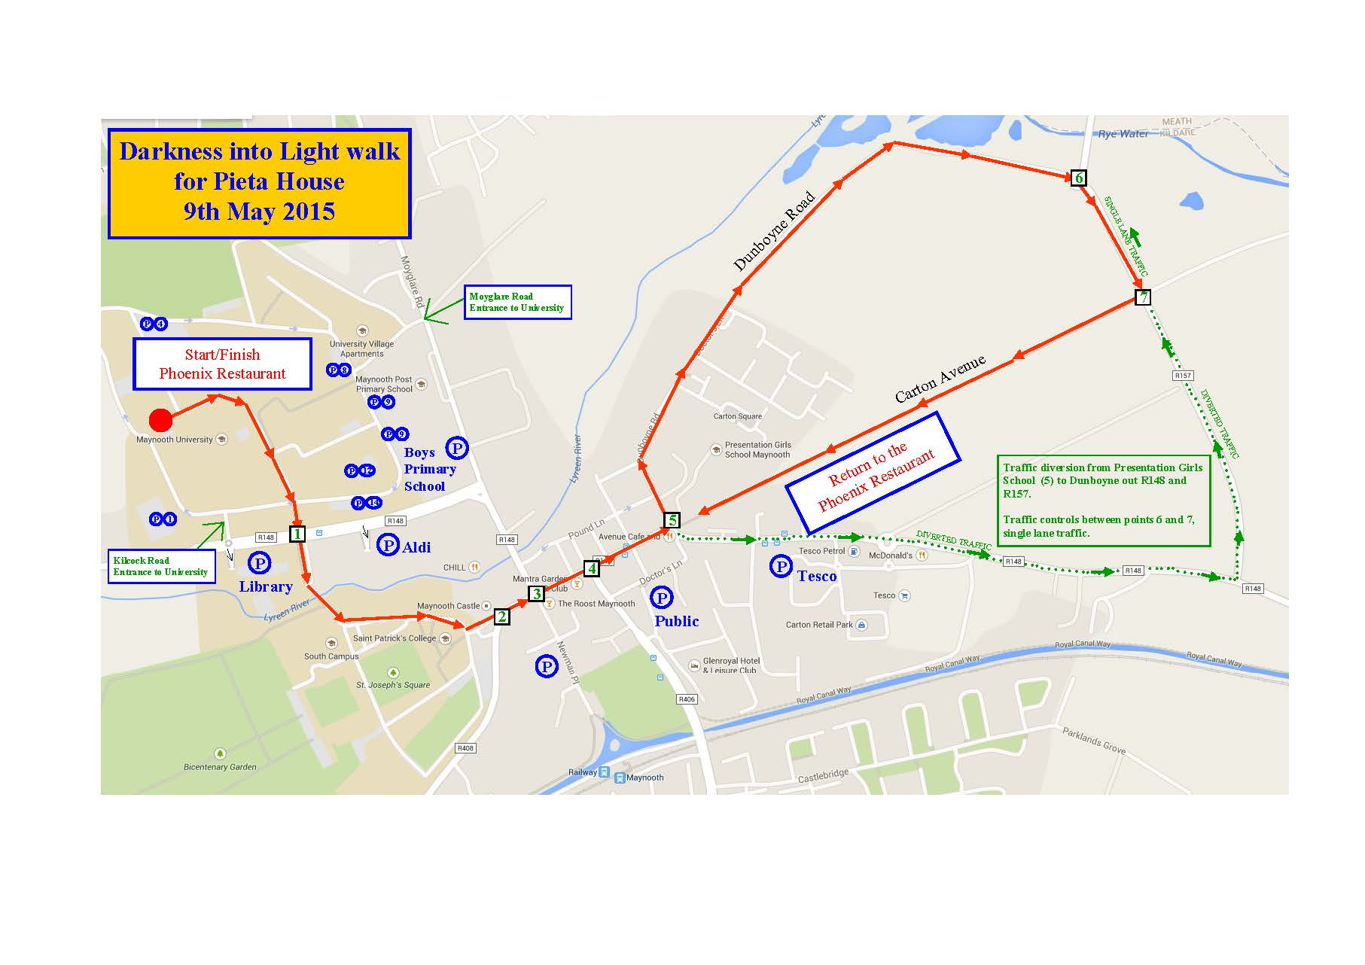
Findings:
I conducted face-to-face interviews with a select group of college students aged between 18-24. The interviews were semi-structured, with open-ended questions that aimed to understand the participants' behaviours, habits, and motivations for consuming wine. Around 70% of the focus group discussions revealed that the target demographic prefers sweet or fruity wines over dry or oaky wines. They also expressed interest in learning more about wine and its origins. Additionally, they stated that the packaging and labelling of wine can influence their purchasing decisions.
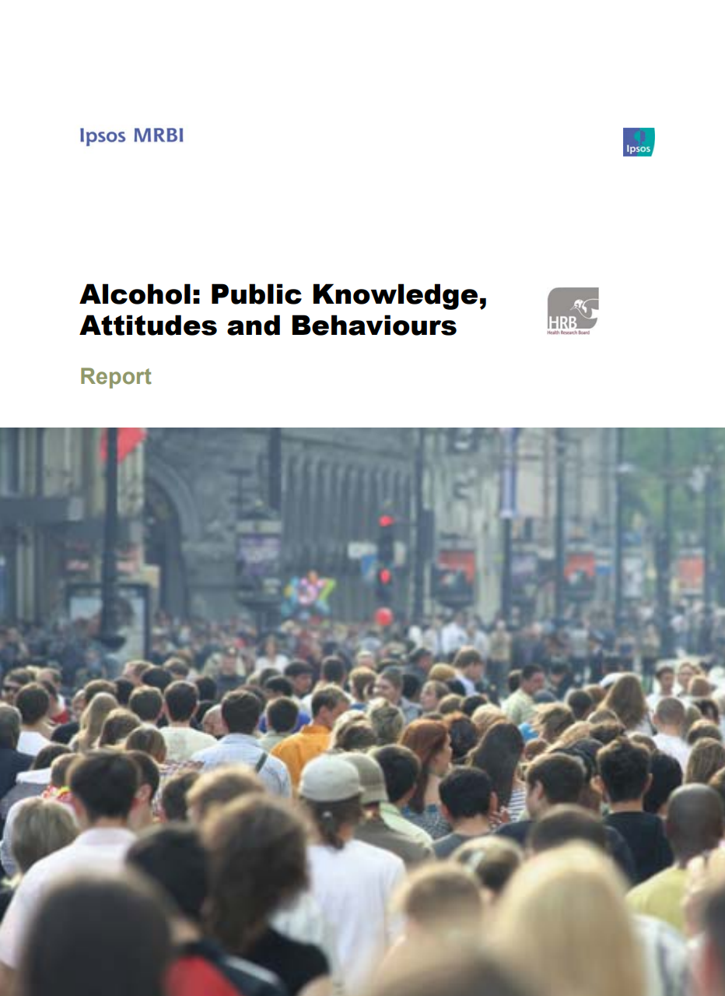
The secondary research showed that millennials, in general, are more health-conscious and tend to choose wine over other alcoholic beverages due to its perceived health benefits. They also tend to choose wine based on its sustainability and eco-friendliness. According to ‘the Alcohol: Public Knowledge, Attitudes and Behaviours Report’ made by the Health Research Board (HRB), “Half (50 per cent) of those age between 18-24 years agree that they would buy more alcohol if supermarkets decreased prices while almost two-thirds (65 per cent) agree that they buy more alcohol when it is on special offer... Almost 6 out of 10 (58 per cent) agree that there should be a minimum price below which alcohol cannot be sold, with agreement strongest among those aged between 35-64 years at 65 per cent. Over one-fifth (21 per cent) do not support minimum pricing for alcohol, with disagreement highest among those aged between 18-24 years at 40 per cent”. ((HRB), Health Research Board)
Overall, these revealed that the college-going population prefers to consume beer and spirits over wine. This was due to the perception that wine is expensive, sophisticated, and unsuitable for house parties and barbecues. Additionally, the lack of knowledge and confidence in selecting the right wine and the perception that wine is not suited for casual settings made the college-going population reluctant to purchase wine from The Vine Tree.

Insights:
From the research findings, there are several opportunities for The Vine Tree to attract the college-going population.
- Education and Knowledge:
Many college-going students are unfamiliar with wine and lack confidence in selecting the right wine. Therefore, educating the population about wine, its flavour, origin, and the distinct types of wine available could attract more customers.
- Wine for Parties:
The feeling that wine is not suited for casual settings like house parties and barbecues was a significant barrier to attracting the college-going population. Offering wines that are suited for party settings, such as light and fruity wines, could help change this belief.
- Price Point:
The perception that wine is expensive was another significant barrier. Offering wines at a more affordable price point could attract more customers from the college-going population.
Definition Phase:
Based on my research findings and insights, I have defined the problem as follows:
How can The Vine Tree attract the college-going population to purchase wine by providing education and knowledge about wine, offering wine that is suited for party settings, and providing wines at an affordable price point?

Potential Steps and Solutions:
After gathering insights from the discovery phase, I will use the following steps to define the problem and ideate potential solutions:
- Persona creation - Based on the user interviews and survey data, I will create a persona that represents the target audience. This will help us better understand their needs and preferences.
- Brainstorming - Using the insights gathered from the previous methods, I will brainstorm potential solutions to engage the target audience and increase footfall to The Vine Tree.
I could use techniques such as stakeholder and empathy mapping. Stakeholder mapping involves visually mapping out people, places or objects involved in these types of scenarios that can affect a business/company successfully, hence they are called stakeholders. Empathy mapping visually understands the target audience's pain points, motivations, and behaviours. They were under a software tool called Mural and the diagrams are shown below.
Major factors and influences involved in this situation are:
- Joan Lowden - The owner of The Vine Tree wants to increase footfall to her shop by engaging with the 18-24 demographic.
- 18-24-year-old college students - The target audience that Joan wants to engage with and sell more wine to.
- Older customers - Joan's current steady clientele buys 1-3 bottles of wine monthly.
- Competitors - Convenience stores and supermarkets that also sell off-sales alcoholic beverages.
- Wine industry experts - People who have expertise in the wine industry and can provide insights into how people choose wine and what informs their choice.
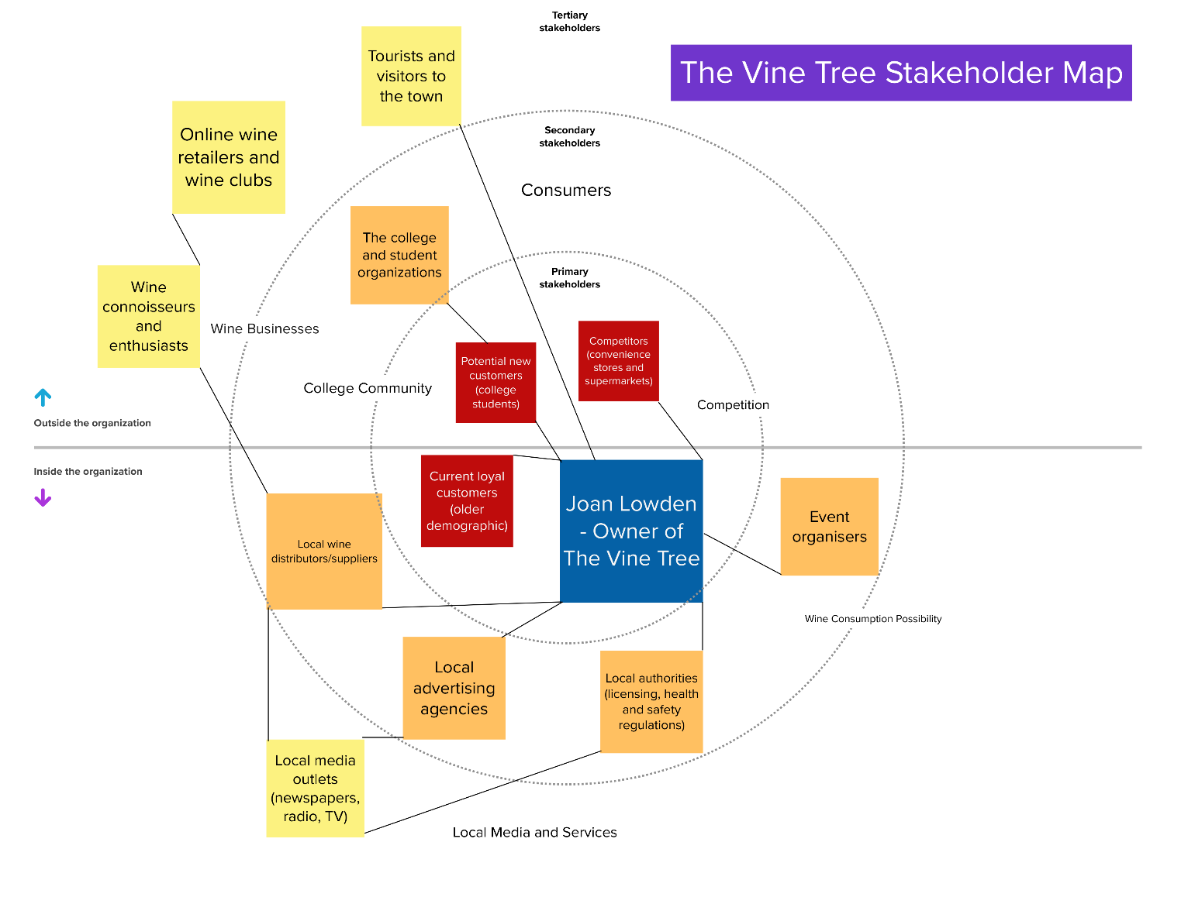
- Event organizers - People who organize BYOB events like barbecues or house parties where people may choose to bring wine.
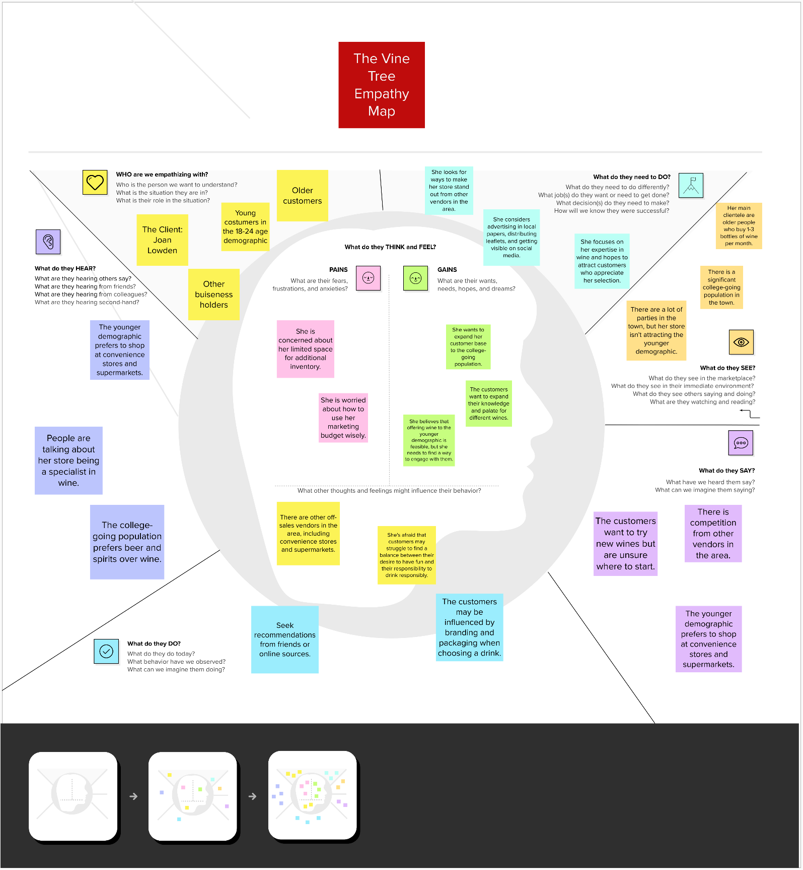
To sum it up from this part of the research, I recommend that The Vine Tree should focus on educating the target demographic about wine and its origins. This can be achieved by hosting wine-tasting events, where attendees can learn about the several types of wine, their origins, and the production process. The Vine Tree can also use social media platforms like Instagram to highlight the distinct types of wine they offer and provide information about their origins and production process. This will appeal to the target demographic's interest in learning about the products they consume.
Another solution could be to offer discounts or promotions specifically for the 18-24 demographic. For example, if I were there, I could offer a student discount or a discount for first-time customers. I can promote these discounts through social media and local college groups.
I could improve the in-store experience for the 18-24 demographic by creating a more youthful and vibrant atmosphere. I can do this by playing music that appeals to this demographic, offering seating areas where they can socialise with friends, and having knowledgeable staff on hand to answer any questions they may have about wine.
Lastly, in terms of packaging and labelling, The Vine Tree can create unique packaging designs that appeal to the target demographic's tastes and preferences. They can also use eco-friendly packaging materials to appeal to the target demographic's concern for the environment.

Possible Conclusion:
Through the discovery phase of my design thinking process, I have identified an opportunity for The Vine Tree to expand its customer base to the younger demographic of college students by educating them about wine and its origins. I recommend hosting wine-tasting events and using social media platforms to display their offerings and provide information about their origins and production process. The Vine Tree can also use unique packaging designs and eco-friendly packaging materials to appeal to the target demographic's tastes and preferences. By implementing these recommendations, The Vine Tree can increase footfall in its store and boost its profitability.
